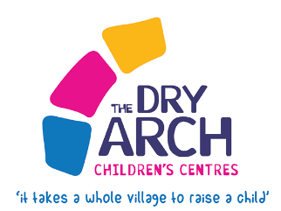
INTER-AGENCY/SELF
REFERRAL FORM
Return to: Manager@dryarchcentre.co.uk

Parent /Carers Details |  | Family Name:
Main Carers Name: |  | DOB:
Other Carers Name: |  | DOB
Email Address for family: |  | Telephone Number/s:
Full Address:  Post Code: |  | Other Parents Address if different:  Post Code:
Child/Children’s Details:
Ante -Natal? | Due date: |  | List school that each child attends:
Child 1: | DOB:
Child 2: | DOB:
Child 3: | DOB:
Child 4: | DOB:
Child 5: | DOB:
Child 6: | DOB:
Please reflect on the needs of the Family below:

Please include details of all other professionals involved:

Please provide details of what your ongoing role will be:

Please indicate if any known disabilities within the family (so reasonable adjustments can be made where necessary)

Informed consent received for referral to Dry Arch is ESSENTIAL. Yes No
(Please note: Parental consent needs to be sought for any young person under 18)
Referred By: | Role: |  | Organisation:
Email: |  | Tele No:

